http://www.unisim.edu.sg/about-unisim/Overview/PublishingImages/UniSIM_logo.gif

**COR165**

**Thinking Critically**

**Tutor-Marked Assignment 2**

**July 2016 Presentation**

Name: Lim Hui Qin

Student ID: Z1610579

# Question 1

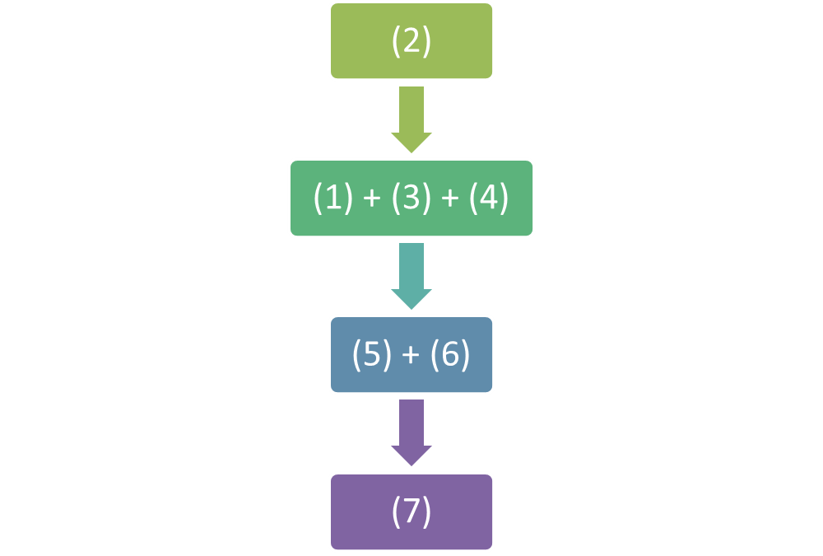

(2) growth in the supply of donated organs has been modest **[directly leads to (3)]**

**[linked reasoning]**

(1) The demand for organ transplant has grown steeply over time and across the globe. **[and]**

(3) current policies that encourage organ donation by appealing to the altruistic instincts of individuals is failing. **[and]**

(4) nothing can be done to reduce the demand **[and]**

**[intermediate conclusion and linked reasoning]**

(5) it is imperative that we consider alternative approaches to increasing organ supply. **[and]**

(6) history suggests that the problem of shortages in scarce goods is best solved by creating a free market **[and]**

**[final conclusion]**

(7) the purchase and sale of organs should be legalised.

# Question 2

## Part A: Assignment

|  |  |
| --- | --- |
| **A** | America will not stop conducting military exercises. |
| **N** | North Korea cannot be persuaded to roll back its nuclear programme. |
| **F** | American’s fear of China will not abate. |
| **R** | It is highly unlikely that a rebellion will happen in North Korea |
| **S** | There will be stability in the Far East. |

## Part B: Outlining

|  |  |
| --- | --- |
| **P1** | If not A, then not N |
| **P2** | If F, then A |
| **P3** | If N, then not S or not R |
| **P4** | F |
| **P5** | R |

**Conclusion:** Not (S)

## Part C: Evaluation

The argument is valid because the premises can be combined to infer the final conclusion of Not (S).

Premise (4) leads to an intermediary conclusion of (A). Premise (2) combined with Premise (1) to give (N). With this, Premise (3) and Premise (5) would result in Not (S). The conclusion of the argument is Not (S), which can be inferred from the premises. Hence the argument is valid.

# Question 3

## Part A: State the argument

The author’s conclusion is “prize money should be equal for event at equal levels”.

The first reason leverages on the “inflexibility of prize money to adapt to prevailing market forces”. This is shown through minimal increase in prize money over the years. Additionally, organizers such as ITF and Challenger often have a fixed budget set aside for prize money.

The second reason is the “difficulty to accurate determine the economic value for each tour”. It difficult for organizers to anticipate the audience viewership garnered from each tournaments. Furthermore adjusting prize money to reflect changing marketplace is challenging in nature due to the dynamics.

## Part B: Identify strength and weakness of argument

The strengths of the argument include the use of relevant examples, statistics and logical reasoning.

The author cited the prize money winners received from each tournament to empathize the discrepancy between prize money and gender. He also uses the published earning of top tennis players to show that prize money only contributes a small portion to the players’ income. He separated the sources of income for tennis players and uses it as a counter argument to account for economic reasons as the drivers for difference in prize money.

The weaknesses of the argument are lack of evidence, one sided references and ambiguity of equality.

However, the author can improve his argument by giving greater details to other sources of income to justify how equal prize money is not unfair to players who are more popular. It is noted that he takes references from male tennis players primarily and did not give a balance view from female’s perspective. While he mentions equal pay at equal level tournament, there is no mention of how to determine the level of difficultly or attributes to use.

## Part C: Respond to argument

I agree with the author’s conclusion that “prize money should be equal for event at equal levels” and this should not be limited to tennis only.

Gender equality is a topic that is prominent is many forums. It is not the first time that women are treated below par to men, despite the many similarities or contributions women made. According to BBC Sports, it is reported that “Men get more prize money in 30% of sports”. The call for equal pay based on tournament level will help to bridge the gender equality gap. Most importantly it fairly rewards female athletes who have trained as hard as or even harder than male athletes.

The idea of reaping what one sow in the case of Djokovic fails to consider the other sources of income athletes receive. It is understandable that one who fetches more should be given more; similar to how popular athletes generate most of their income from product endorsements and agency fees. This is a reward for the attention they receive or the attraction they have over audience. To factor this into prize money is challenging and impractical because popularity is not measurable and the competition spirit in sports would be lost if attention is focused on the athletes’ fame rather than the competition itself.

Stacey Allaster, Women's Tennis Association chief executive mentioned that “it doesn’t make any sense … great female athletes not having greater share of sponsorship and exposure … we need people to lead and people to invest.” The match between Serena and Venus Williams in 2015 U.S. Open Women’s tournament had its tickets sold out more quickly than men’s tournament. These points point to the fact that female athletes playing sports are as attractive as male. Promoting equal pay for tournaments is a fair and unbiased approach to place the right focus on the game and reward athletes for their achievements.

While there are no existing rules and regulations to categorize tournaments across various organizers based on level of difficultly, equal level in tournaments can be guided by the existing categories that leverages on age group and single player or team based. It is challenging to have a standardized method of classifying tournaments organized by different committees, however, a first step that can be taken would be for organizers to draft out and standardize the prize money in accordance to current tournament enrollment standards.

In conclusion, prize money should be equal for event at equal levels because athletes deserve the same recognition for their achievements, regardless of their gender or their appeal to public.